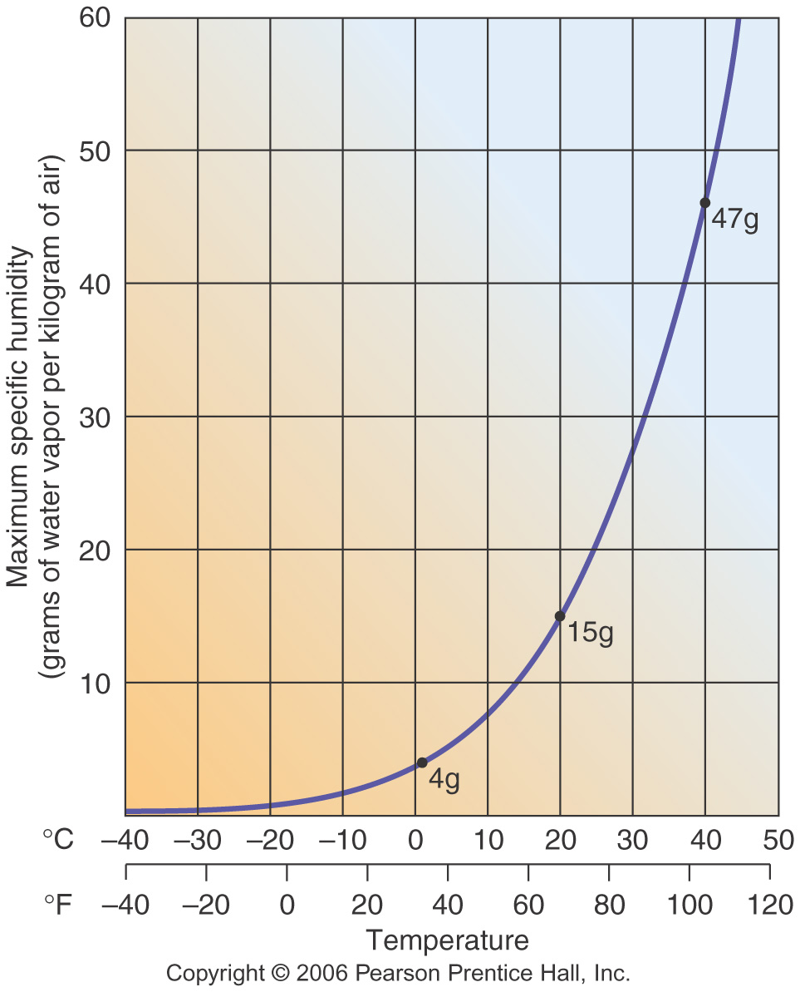
TEMPERATURE (°C) | CAPACITY (grams) | ACTUAL HUMIDITY (grams) | RELATIVE HUMIDITY (%)
-10 |  | 1
-5 |  | 2
5 |  | 2
10 |  | 5
25 |  | 15
35 |  | 15

C.Burrows

