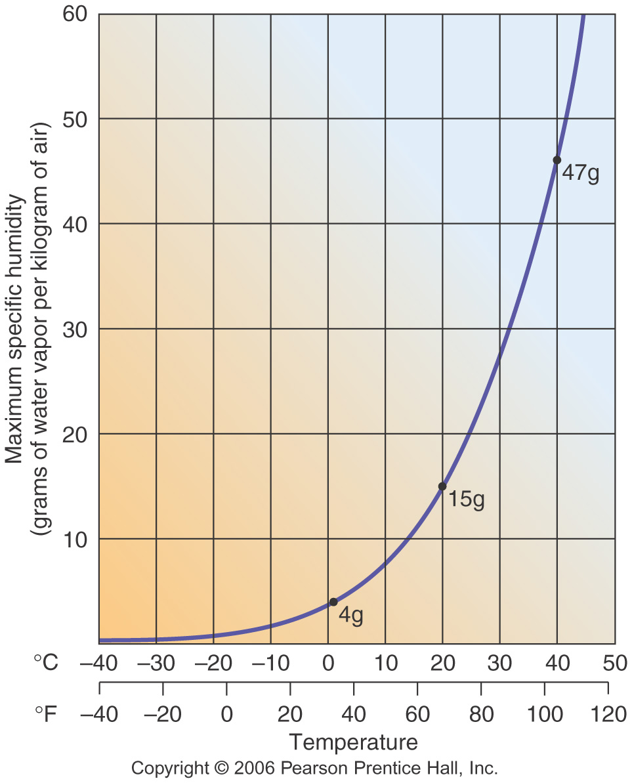
TEMPERATURE (°C) | CAPACITY (grams) | ACTUAL HUMIDITY (grams) | RELATIVE HUMIDITY (%)
5 |  | 2
10 |  | 2
25 |  | 2
35 |  | 2
Without adding or removing water, as air temperature increases, relative humidity ________________.
TEMPERATURE (°C) | CAPACITY (grams) | ACTUAL HUMIDITY (grams) | RELATIVE HUMIDITY (%)
35 |  | 10
30 |  | 10
25 |  | 10
5 |  | 10
Without adding or removing water, as air temperature decreases, relative humidity _______________.
Between 25 and 5°C, the air became _____________________.
The temperature that this happened is called the ________________________.
As the air cooled BELOW the dew point, the excess water left the air in a process called ______________.
This excess water can create _____________ in the sky or ____________ on cool surfaces.
C.Burrows

